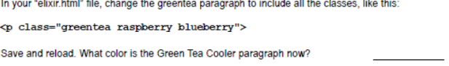
The green paragraph is now purple.

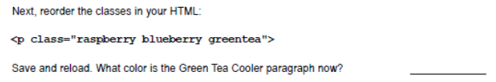
The green paragraph is still purple.


The green paragraph is green again now.


The green paragraph is now purple.

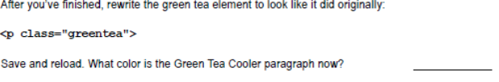
The green paragraph is green again now.

